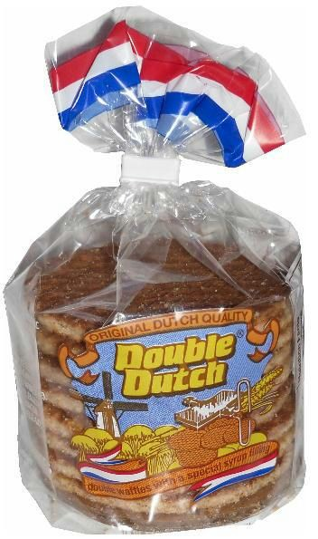

STROOPWAFEL ORDER FORM

Name: Club:

 | Name | # of sleeves ($3.00  each) | # of boxes ($30 each) | Total | Paid (✓)
1
2
3
4
5
6
7
8
9
1
0
1
1
1
2
1
3
1
4

